
Company
Logotype

Cone Beam Computed Tomography- Report



Porur Dental X-rays & CBCT

Patient Name : Mr. Saravanan | Date of Report : 02.07.2024
Age/ Gender : 45 years/ Male | Region of Interest : CBCT Full Skull
Referring doctor: Dr. M. Balamurali Sai | Indication : Implant assessment
Clinical Notes: Nil
PATIENT INFORMATION

CBCT- Full Skull provided
CBCT – IMAGE DETAILS

RADIOGRAPHIC INTERPRETATION

- Complete loss of crown and root structure in relation to 18, 23, 28, 38, 46.
- Horizontally impacted tooth: 48 impinging on the distal root of 47 is evident.
- The alveolar bone in relation to upper and lower arch is present with normal trabecular pattern.
- Presence of hyperdense implant screws in relation to 12, 13, 14 is evident.
- Hyperdense crown structures present in relation to 11, 22, 27, 34, 36, 37.

IMPLANT ASSESSMENT

 | 36 region | 46 region
Sub-Crestal (in mm) | 6.5 | 5.6
Mid- Crestal (in mm) | 9 | 9
Distance between alveolar ridge and the inferior alveolar nerve canal (in mm) | 13.7 | 14.9
Distance between alveolar ridge and the inferior border of mandible (in mm) | 23.8 | 26.1

RADIOGRAPHIC IMPRESSION

- Partially edentulous maxillary and mandibular alveolar ridge.
- Crowns in relation to 11, 22, 27, 34, 36, 37.
- Implant in relation to 12, 13, 14.
- Impacted tooth : 48

Kindly correlate with clinical findings


IMAGES FOR REFERENCE

RECONSTRUCTED PANORAMIC VIEW

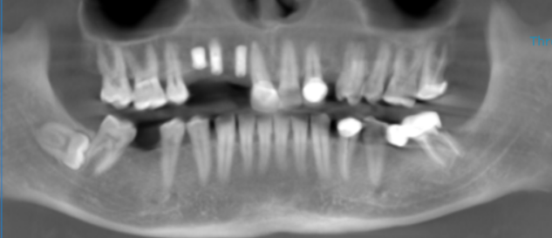
3-DIMENSIONAL VIEW

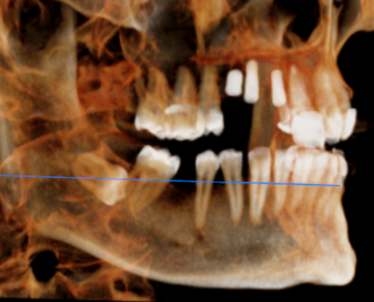
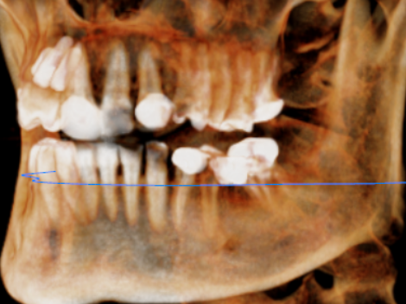

CROSS SECTIONAL VIEW

36 region | 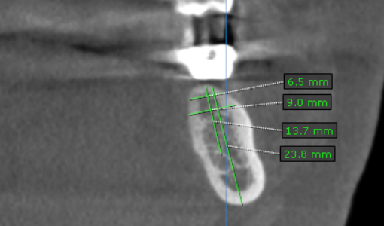
46 region | 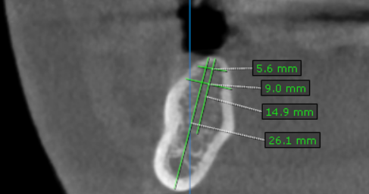

**** End of report ****

